**Project Development Phase**

| Date | 11 November 2022 |
| --- | --- |
| Team ID | PNT2022TMID16827 |
| Project Name | Project – Visualizing and Predicting Heart Diseases with an Interactive Dashboard |

Sprint-1

**Registration**-Can register for the application by entering my email, password,

and confirming my password

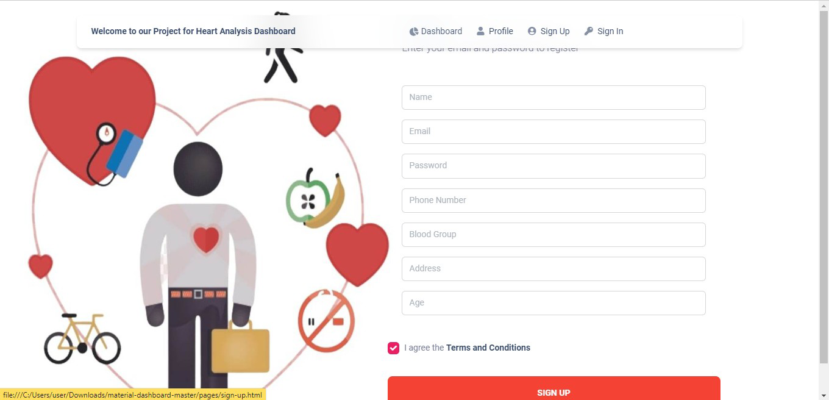

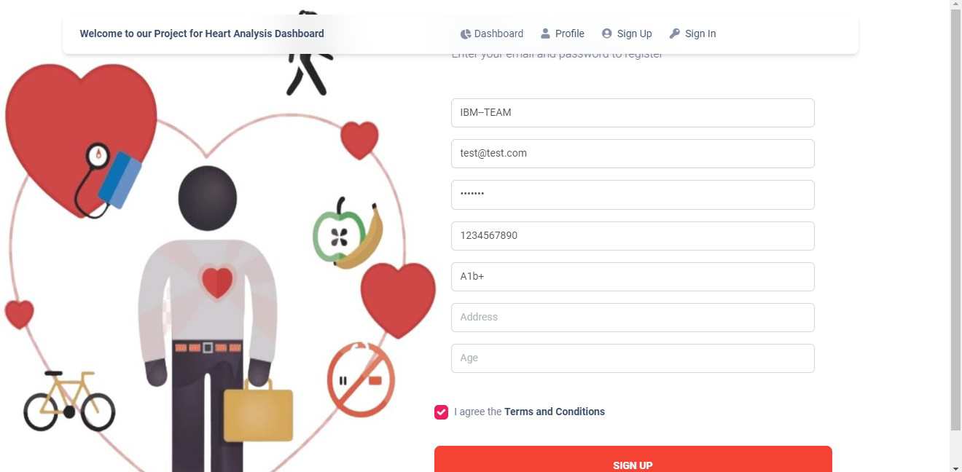

**Login -** Can log into the application by entering email/PhoneNumber & password

